Unit 13. Managing File Systems
What This Unit Is About
This unit illustrates the methods that can be used to manage the AIX file systems.
What You Should Be Able To Do
After completing this unit, students should be able to:
- Monitor file system growth and control growing files
- Capacity plan for file system growth
- Manage file system disk space usage
- Implement basic file system integrity checks
How You Will Check Your Progress
Accountability:
- Checkpoint questions
- Exercises

13.1 Objectives
After completing this unit, students should be able to:
- Monitor file system growth and control growing files
- Capacity plan for file system growth
- Manage file system disk space usage
- Implement basic file system integrity checks
Notes:

13.2 Space Management
- File systems expand upon notice, NOT automatically
- To keep from running into problems:
- － monitor file system growth
- － determine causes
- － control growing files
- － manage file system space usage
- － control user disk usage
- － defragment file system
Notes:
- Although AIX Version 4 provides for dynamic expansion of a file system, it does not expand the file system on the fly. The system administrator must continually monitor the file system growth and use the SMIT option to expand it before the file system gets full. If the file system becomes 100%full then the users will receive “out of space” messages on file system expansion.
- For example, The df command can be run through cron (the job scheduler) so that a regular check is done of the space available in the file system and perhaps a report created, cron will be covered in a later unit.

13.3 Listing Free Disk Space
- The df command displays information about total space and available space on a file system
# df
Filesystem 512-blocksFree %Used Iused %Iused Mounted on
/dev/hd4 16384 7600 53% 1243 30% /
/dev/hd2 1630208 101648 93% 22217 10% /usr
/dev/hd9var 24576 22360 9% 257 8% /var
/dev/hd3 24576 21520 12% 144 3% /tmp
/dev/hd1 24576 5160 79% 518 16% /home
/dev/lv00 24576 3172 86% 620 22% /home/john
Notes:
- This is an important command to be aware of and use frequently. If you run out of space in a file system (especially / or /tmp), system corruption could occur.
- The df command lists the free space on all mounted file systems.
- df -I shows space used
- df -k reports free space in 1 KB blocks

13.4 Control Growing Files
- /var/adm/wtmp
- /var/spool/*/*
- /smit.log
- /smit.script
- /etc/security/failedlogin
- /var/adm/sulog
Notes:
- Growing files should be monitored and cleaned out periodically. These are some of the files that grow.
- If accounting is turned on, /var/adm/wtmp will be kept to a reasonable size.
- /var/adm/wtmp , /etc/security/failedlogin and /var/adm/sulog are needed because they contain historical data regarding login activity. Thus, these files should always have a few days worth of login activity kept in them. If accounting is not turned on, to capture the data to archive it, use who –a on /var/adm/wtmp and /etc/security /failedlogin and redirect the output to a save file. Then the file can be purged by using cat /dev/null redirected to either /var/adm/wtmp or /etc/security/failedlogin. /var/adm/sulog can be edited directly.

13.5 Listing disk usage
- The du command can be used to list the number of blocks used by a file or a directory
# du /home︱sort -r -n
624 /home
392 /home/fred
98 /home/tom
54 /home/mary
52 /home/liz
23 /home/suzy
2 /home/guest
1 /home/steve
Notes:
- There may be a number of files or users that are causing the increase of use in a particular file system. The du command will help to determine the cause.
- du gives information in 512-byte blocks, by directory. With the -a option, it is given by file. If used with sort on the first column in descending order, it can be an aid in determining which files/directories are the largest. Then using an ls -l, you can determine the file/directory’s owner.

13.6 Fragmentation Considerations
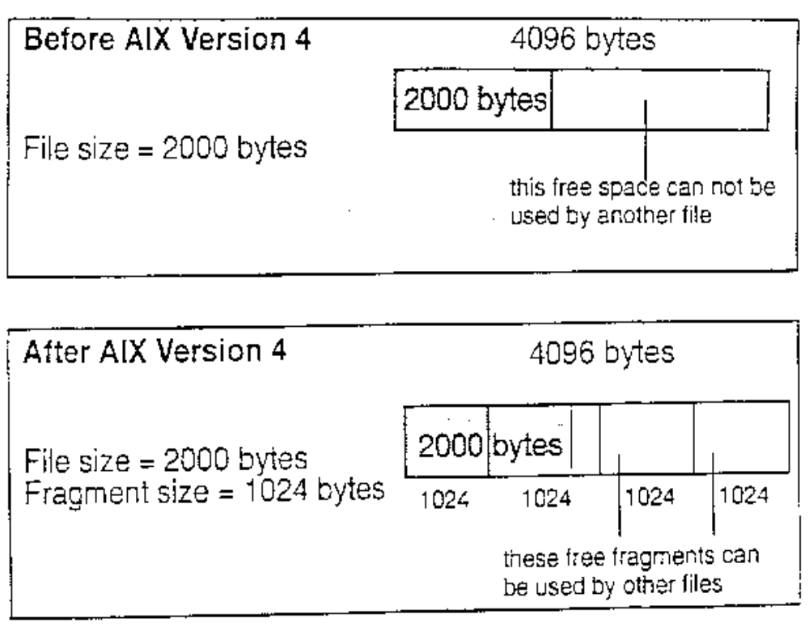Considerations to be made:
- Disk space allocation
- Disk space utilization
- I/O activity
- Free space fragmentation
- Fragment allocation map

Notes:
- In AIX Version 4, as many whole fragments as necessary are used to store a file or directory's data. Consider that we have chosen to use a JFS fragment size of 4KB and we are attempting to store file data which only partially fills a JFS fragment. Potentially, the amount of unused or wasted space in the partially filled fragment can be quite high. For example, if only 500 bytes are stored in this fragment then 3596 bytes will be wasted. However, if a smaller JFS fragment size, say 512 bytes was used, the amount of wasted disk space would be greatly reduced to only l2 bytes. It is, therefore, better to use small fragment sizes if efficient use of available disk space is required.
- Although small fragment sizes can be beneficial in reducing disk space wastage, this can have an adverse effect on disk I/O activity. For a file with a size of 4KB stored in a single fragment of 4KB, only one disk I/O operation would be required to either read or write the file. If the choice of the fragment size was 5l2 bytes, eight fragments would be allocated to this file and for a read or write to complete, several additional disk I/O operations (disk seeks, data transfers and allocation activity) would be required. Therefore, for file systems which use a fragment size of 4KB, the number of disk I/O operations will be far less than for file systems which employ a smaller fragment size.
- For file systems with a fragment size smaller than 4KB, there is likely to be an increase in allocation activity when the size of existing files or directories are extended.
- Free space fragmentation can occur much more within a file system that uses smaller fragment sizes.
- The fragment allocation map, used to hold Information about the state of each fragment for each file system, is held on the disk and in virtual memory. The use of smaller fragment sizes in file systems results in an increase in the length of these maps and therefore requires more resources to hold.

13.7 Compression Considerations
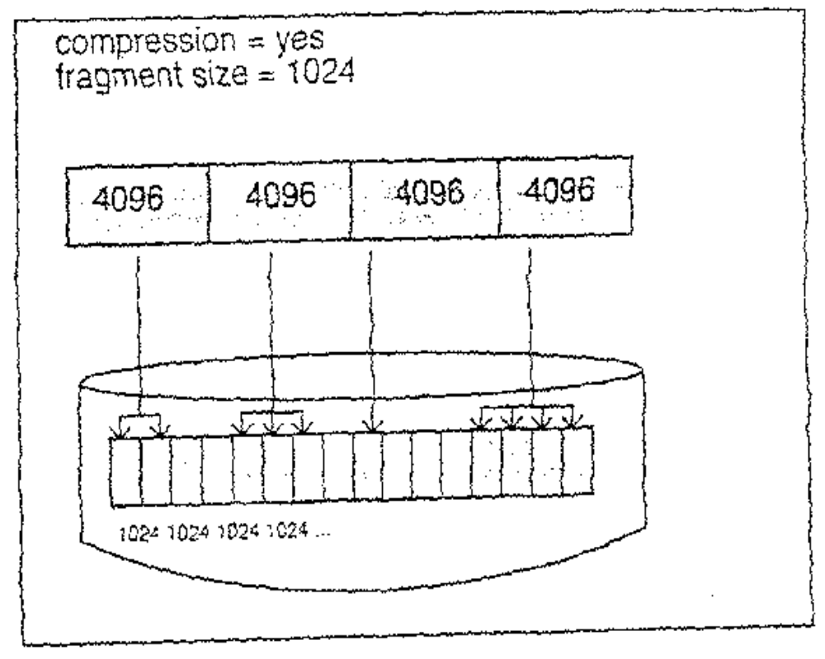
Considerations to be made:
- Degradation in file system usability
- Disk space utilization
- Processor load
Notes:
- Unlike the JFS fragment support, which treats logical blocks of files and directories less than 32K bytes in size differently to those that are larger, the JFS data compression support will use the same data compression technique for all logical blocks of files, irrespective of file size and fragment size. It does, however, enforce that the fragments used for the files logical blocks are contiguous.
- The obvious advantage of the use of data compression supplemental to fragmentation is that there is no restriction to the file size, and so compression will be efficient for both small and large files.
- In addition to increased disk I/O activity and free space fragmentation problems, file systems using data compression have the following performance considerations:
- Degradation in file system usability arising as a direct result of the data compression /decompression activity. If the time to compress and decompress data is quite lengthy, it may not always be possible to use a compressed file system, particularly in a busy commercial environment where data needs to be available immediately.
- All logical blocks in a compressed file system, when modified for the first time, will be allocated 4096 bytes of disk space, and this space will subsequently be reallocated when the logical block is written to disk. Performance costs are, therefore, associated with this allocation, which does not occur in non-compressed file systems.
- In order to perform data compression, approximately 50 CPU cycles per byte are required and about 10 CPU cycles per byte for decompression. Data compression, therefore, places a load on the processor by increasing the number of processor cycles.

13.8 Control User Disk Usage – Quotas
- Based on the Berkeley Disk Quota System
- Allows control of disk storage on a user or group basis
- Quotas have three parameters:
- Soft limits
- Hard limits
- Grace period
- Quotas are optional and used for:
- Limited disk space environment
- File system requiring more security
- High file system usage, for example University.
Notes:
- The disk quota system allows system administrators to control the number of files and data blocks that can be allocated to users or groups.
- The disk quota system establishes limits based on three parameters:
- User's or group's soft limits - defines the number of 1KB blocks or files below which the user SHOULD remain.
- User's or group's hard limits - defines the MAXIMUM amount of disk blocks or files the user can accumulate under the established quotas.
- Quota grace period - allows the user to exceed the SOFT limit for a short period of time (default is one week). Should the user fail to reduce usage below the soft limit during the specified time, the system will interpret the soft limit as the maximum allocation allowed, and no further storage will be allocated to that user. The user may reset this condition by removing enough files to reduce usage below the soft limit.
- The disk quota system tracks user and group quotas in the quota.user and quota.group files in the root directories of the file systems enabled with quotas. These files are created with the quotacheck and edquota commands and are readable with the quota commands.
- Quotas are optional. You should consider implementing the disk quota system under the following conditions:
- Your system has limited disk space
- You require more file system security
- Your disk-usage levels are large, such as at many universities
- If these conditions do not apply to your environment, you may not want to create disk-usage limits by implementing the disk quota system.

13.9 Setting Up Quotas for a User
Step 1:
# vi /etc/filesystems
/home:
dev = /dev/hd1
vfs = jfs
log = /dev/hd8
mount = true
check = true
quota = userquota,groupquota

options = rw
quota = userquota,groupquota

Notes:
- To implement disk quotas, edit the file /etc/filesystems or run the chfs command to include the quota, userquota and groupquota configuration attributes. For example, to enable user quotas on a file system, add to the appropriate stanza in the /etc/filesystems file:
- quota = userquota
- To enable both user and group quotas on a file system, enter:
- quota = userquota, groupquota
- The following example entry establishes user and group quotas for the /home file system.
- dev = /dev/hd1
- vfs = jfs
- log = /dev/hd8
- mount = true
- check = true
- quota = userquota, groupquota
- options = rw

13.10 Setting Up Quotas
Step 2:
# edquota -u username
For example:
# edquota -u lola
Quotas for user lola
/home: blocks in use: 0, limits (soft = 0, hard = 0)
inodes in use: 0, limits (soft = 0, hard = 0)

"/tmp/EdP.aE5ADFW" 3 line, 125 character
Notes:
- The edquota command creates and edits quotas. It creates a temporary file that contains each user's and group's current disk quotas. It determines the list of file systems with established quotas from the /etc/filesystems file so that quotas can be added or modified. To use the edquota command, the EDITOR variable must be set. For example, export EDITOR=/usr/bin/vi
- By default, or when used with the –u option, the edquota command edits the quotas of one or more users. When used with the -g option, the edquota command edits the quotas of one or more groups. The -p option identifies a prototypical user (UserName) or a prototypical group (Proto-GroupName) and duplicates these quotas for a specified user or group.
- The default grace period is one week during which quotas can exceed the number of 1 KB blocks listed under soft limit. After this time the soft limit is imposed as a hard limit. The default of seven days can be changed, but must be changed for everyone.
- When the editor is exited, the edquota command reads the temporary file and modifies the binary files to reflect any changes.

13.11 Setting the Grace Period
Step 3:
To set the grace period time limits:
- edquota -t -g edits grace -period for groups
- edquota -t -u edits grace period for users
# edquota -t
Time units may be: day, hours, minutes, or seconds
Grace period before enforcing soft limits for users:
/home: block grace period: 0 days, file grace period: 1 day
"/tmp/EdP.aE5IDFD" 3 lines, 165 characters
Notes:
- This command enables you to set the grace period, which is the time for which the limits can be exceeded before the hard limits are enforced.
- A user can exceed established soft limits for a default grace period of one week. Upon expiration of the grace period, the soft limit is enforced as a hard limit. The grace period can be specified in days, hours, minutes or seconds. A value of 0 indicates that the default grace period is imposed; a value of 1 second indicates that no grace period is granted.
- -t When invoked with the -t flag. edquota changes the grace period during which quotas can be exceeded before the soft limit is imposed as a hard limit
- -tu the grace period is set for all file systems with user quotas specified in the /etc/filesystems file
- -tg the grace period is set, for all file systems with group quotas specified in the /etc/filesystems file

13.12 Managing Quotas
- To turn on quotas:
# quotaon /home
- To ensure the correct limits are used:
# quotacheck -a
- To display the current user and/or group quota usage:
# repquota -a
Notes:
- The quotaon command enables disk quotas for one or more file systems specified by the file system parameter.
- By default, both user and group quotas are enabled:
- -u enables only user quotas
- -g enables only group quotas
- -a all file systems with disk quotas, as indicated by the /etc/filesystems
file, are enabled
- By default, both user and group quotas are disabled.
- The quotaoff is used to turn off quota enforcements. The limits will not be erased. You can turn off either all quota checking (with the –a option) or individual file systems (quotaoff /home).
- Note that changes to the grace period are not in effect unless the quotaoff and quotaon commands are executed after the change.
- The quotacheck command will ensure that the current limits (if there has been a change) and the quota files are in sync. Use this command after any changes have been made to the individual or group limits.
- The repquota command will display the current user and/or group usage as well as the current grace period in force. This information can be per file system or all file systems using the -a option.
- repquota reads the quota.user and quota.group files in the root directories of all file systems enabled for quotas to report this information.
- You have to be the root user to run all the commands associated with setting up Berkeley disk quotas. As a regular user you can see where you stand against your quotas by running the quota command from the command line.

13.13 Defragmenting a File System
- The defragfs command increases a file system's contiguous free space
- The file system must be mounted
/usr/sbin/defragfs [-q ︱ -r ] filesystem
Options:
-q Reports the current state of the file system
-r Reports the current state of the file system and the state that would result if the defragfs command is run without either
-q or –r
Notes:
- Some of the information that is returned with the defragfs command is:
- Number of Fragments Moved: Tells you how many data blocks need to be moved.
- Number of Logical Blocks Moved: Tells how many non-contiguous blocks that are in the system currently and how many that will be relocated, if possible.
- Number of Allocation Attempts: This is the required number of calls to the allocation routine to defragment the file system.
- Number of Exact Matches: This is the number of exact matches, based on file sizes, that are in the allocation thus allowing the file to be rewritten contiguously.
- Note: Sometimes the estimates provided when running defragfs with the -q or -r
options will return different results than what is actually done when running
defragfs without any options.
13.14 Verify a File System
- Command syntax:
fsck [-p︱-y︱-n ] [-f] [file system]
- Checks Journal Log
- Checks inodes, indirect blocks, data blocks, free lists
- If no file system name is specified, the fsck command will check all filesystems which have the check=true attribute set in the /etc/filesystems
- Problems are reported in the /lost+found directory
Notes:
- A file system can be verified using the fsck (file system check) command.
- This check consists of a number of stages, including:
- check the journal log for errors
- check the blocks to ensure that each block is either allocated to a single file or is in the free list
- check file sizes
- check directory entries
- The -p option (preen) is used to check a file system making only minor changes without bothering the user. The command when run under SMIT uses this option.
- The -y option (yes) or -n (no) option is used to indicate a yes or no answer to all questions. The yes option is typically used to recover a badly damaged file system. Using the -y option will allow fsck to discard some badly damaged files.

13.15 Documenting -File System Setup
- Run the lsfs command
- Get the contents of the /etc/filesystem file
- Run the df command to check free space
- Check all the mounted file systems by running the mount command
Notes:

13.16 Checkpoint
Exercise - File System Management
1. What command can you use to determine if a file system is full?
2. What two commands can be used to find the files and users that are taking the most disk space?
3. Which statement closely describes the functionality of the soft limit in disk quotas?
a. Provided the user stays below the hard limit they can indefinitely exceed the soft limit.
b. It is the value that the user can exceed for a given period which, by default, is 7 days.
- The hard and the soft limit added together specifies the absolute
maximum disk space that a user can use.

13.17 Unit Summary
- File system management does not just happen on the system. File systems need to be regularly monitored to ensure that they do not run out of space
- Also to ensure the integrity of file systems, checks have to be carried out whenever a file system corruption is suspected

